(Approx. 782 words)

Review of the WOW! Computer
By Jon Mazur, President, CPUser Group, PA
http://cpusergroup.apcug.org
Cpusergroup (at) hotmail.com

How many of you think computers are still hard to use? Well I think I have the answer for you. I recently had the chance to review quite possibly the world’s easiest computer, from setup to actual use. I’m talking about the WOW! Computer from FirstStreet. My 72 year old brother was actually looking to purchase a new computer and had asked me to do a little research on computers that would be easy for him to use. I stumbled upon the WOW and suggested he check out some videos I found for him online. After a few back and forth discussions with him, he decided to go for it. He got in to computers in 1995 and after 12 years of frustration using Windows, he had me convert his two other machines to Linux and he has never looked back. The reason that I mention Linux is that the WOW actually runs a custom version of Linux called Tiny Core Linux. After he found that out it was a no brainer.

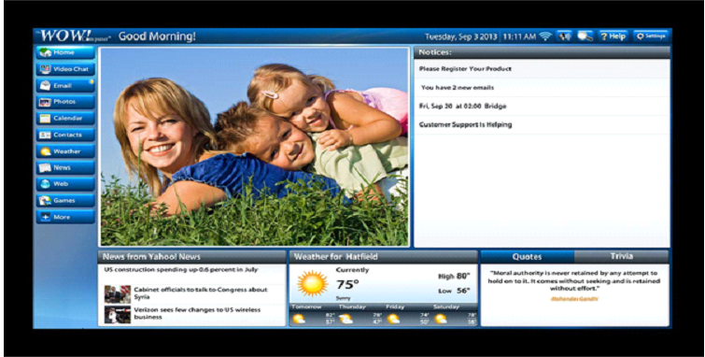

Here are some highlights of the WOW! Computer:

- Innovative touch screen design - one finger can control everything! (even comes with a stylus so you don’t smudge the screen)
- Easy setup -- just plug in the power and your high-speed Internet connection & you’re online
- Email is easy with large print and simple instructions
- One-touch access to many popular web sites plus simple browsing to the rest of the Internet
- Built-in video (Skype) chat, games, calendar, and much, much more!
- NEW! Text-to-voice reads your email to you
- COMING SOON! Voice dictation; speak your emails instead of typing

Once my brother received his computer it took no more than 10 minutes for him to set it up and he had it working and online in about 15 minutes and he is not that computer savvy. The computer, as mentioned before, runs Linux but has a custom front-end interface that is truly user friendly. See the above photo which is what you see when the unit is powered on. The use of email, web surfing, video chatting, photo viewing, CD/DVD playback and much more are all included. Other key points to keep in mind are listed below.

- 27-year old U.S. based company (Virginia)
- 1-month risk free trial (no questions asked)
- Lifetime tech support (phone and remote access)
- U.S. based tech support
- No hidden fees
- No sales tax (at least not in Pennsylvania)
- $50 shipping charges
- Free HP printer (-$50 if you already have one)
- Easy setup
- Closed ended software system
- Runs Linux operating system
- Company handles all updates
- Cost $1079 with the printer or $1029 without

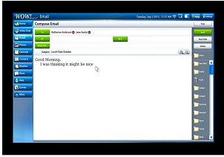

Product Specifications:
- CPU - Intel® 847 Celeron Dual Core Processor
- Monitor - 22" High Definition, 16:9 widescreen panel (1920 x 1280 pixels)
- Touch Panel - Multi Touch Screen
- Graphics Card - AMD® Radeon™ HD 6310 Discrete-Class Graphics
- Memory - 2G DDR3 / DDR3 SO-DIMM x 2 Slots
- Wireless LAN - 802.11 b/g/n
- Hard Disk Drive - 500GB 3.5" SATA II
- Optical Drive - Tray-in DVD Super Multi (plays CD’s too)
- Speaker - Two built-in, front-facing 3W Stereo Speakers with SRS Premium
Sound Technology
- Webcam - Built-in 1.0 MP Webcam and Microphone
- Rear Input/Output - 4 USB 2.0 ports, 1 microphone in, 1 earphone out, 10/100/1000
LAN jack
- Side Input/Output - 6 in 1 memory card reader, 4 USB 2.0 ports(one with super charger), 1 DC jack
- Power - 65W AC Adapter
- Wired Keyboard/Mouse - Keyboard and Mouse included
- Supports HP printers only (for now)
- Dimensions - 22" W x 16 3/8" H x 10 1/8" D (including space needed for stand)
- One year hardware warranty

Conclusion:

This is truly a great computer for those of you who are tired of the Windows or Mac rat race or who just want to simplify your computing life. My brother, for the first time in many years, truly is enjoying using his computer. A couple of things to keep in mind. The computer uses a closed ended software system. Meaning you cannot install any software on it yourself. So if this is something that you like to do, then this system is definitely not for you. Also the cost of the computer is $1079 with the printer or $1029 without. This may be a little steep for most people but keep in mind that you are getting lifetime tech support that is U.S. based. In closing I would say that this is a system that is pretty much maintenance and worry free.

You may contact me at cpusergroup@hotmail.com if you need further info on this system or visit the FirstStreet website at: http://tinyurl.com/lces9wu

http://www.firststreetonline.com/Electronics+amp+Gadgets/Computer+amp+Office/WOW+Computer+with+22+Inch+Monitor.axd

